**Assignment No. 15**

**Create serverless computing service**

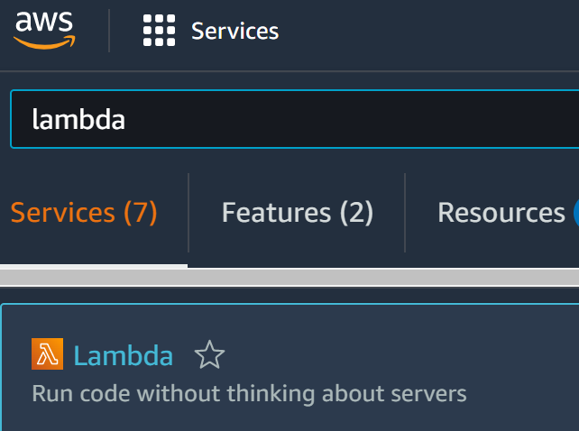

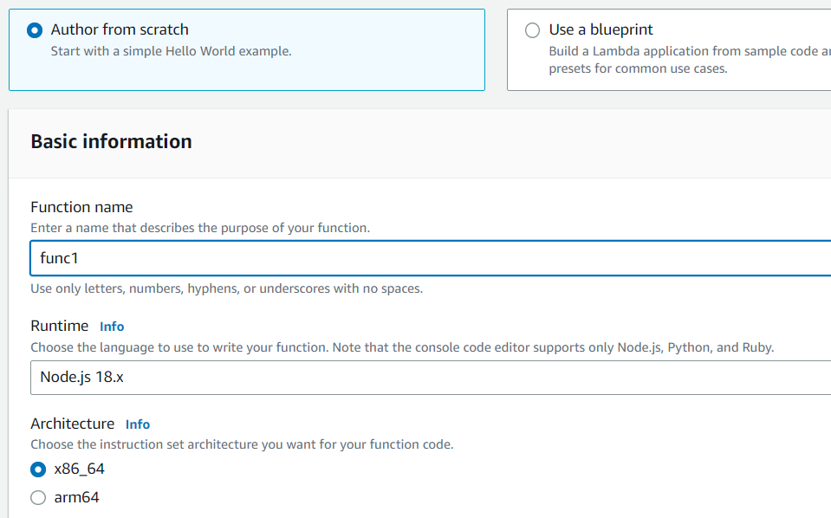

**Type funtion name,select Runtime as “Node.js 18.x” and architecture as “x86_64”.Click on “Create function”**

**Visit** **aws.amazon.com** **and Sign in.Go to Search box,type lambda and click on “Lambda”.Now click on “Create function”**

**1.….**.

**2.**

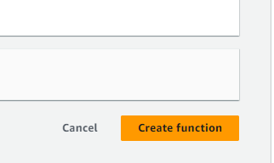 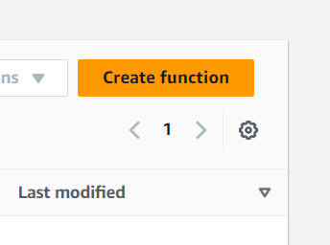

**s**

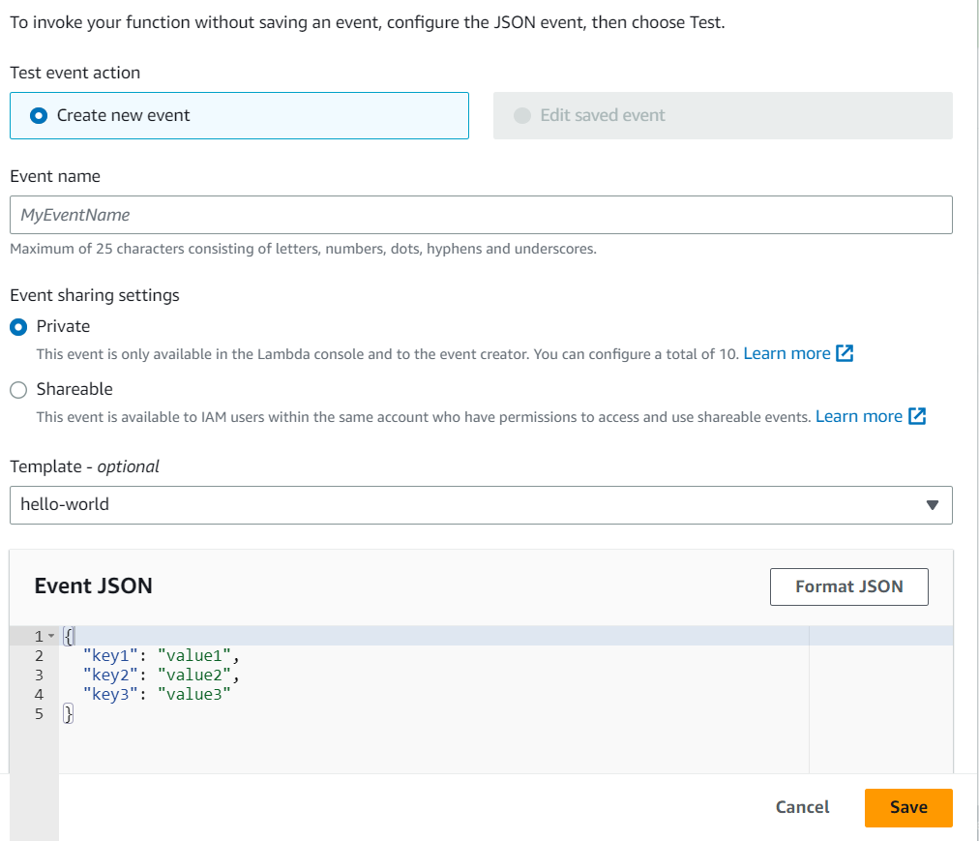

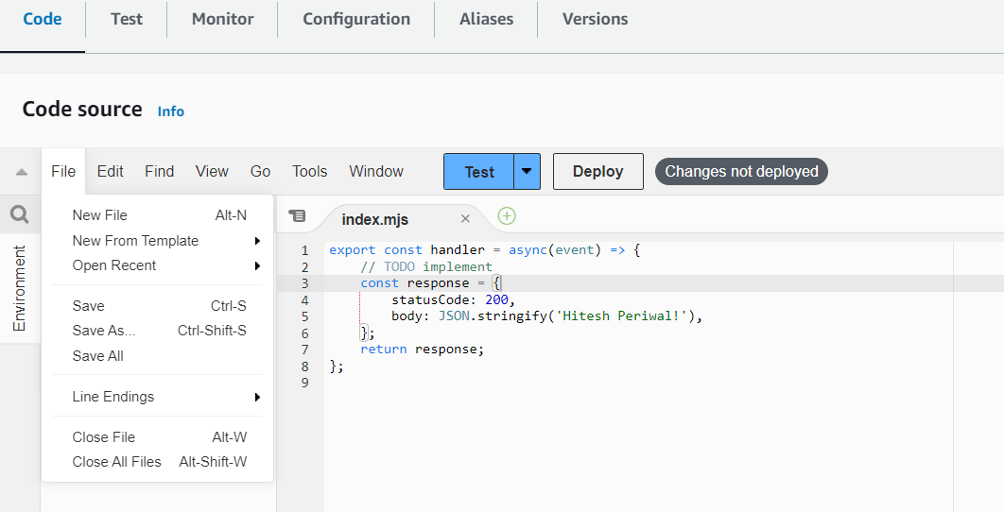

**Select “Create new event”,give event name,event sharing as private,select any template(optional) and click on “Save”**

**Go to Code section.You may edit the code and save it.Click on Test dropdown and select “Configure test event”**

**3.**

**4.….**.

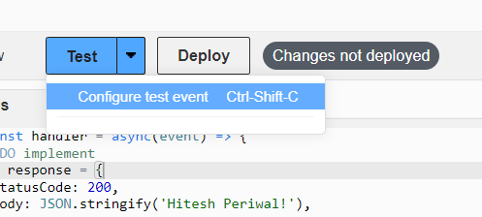

**Go to configuration ,select Function URL and click on “Create function URL”**

**Now test the event by clicking on “Test” and deploy it by clicking on “Deploy”**

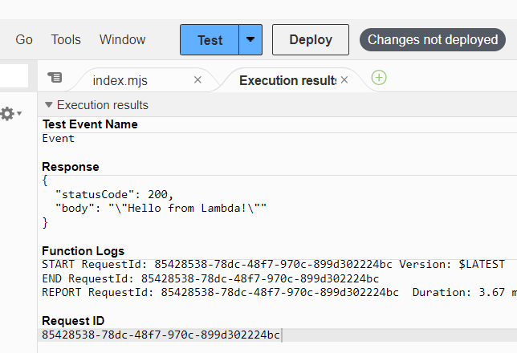

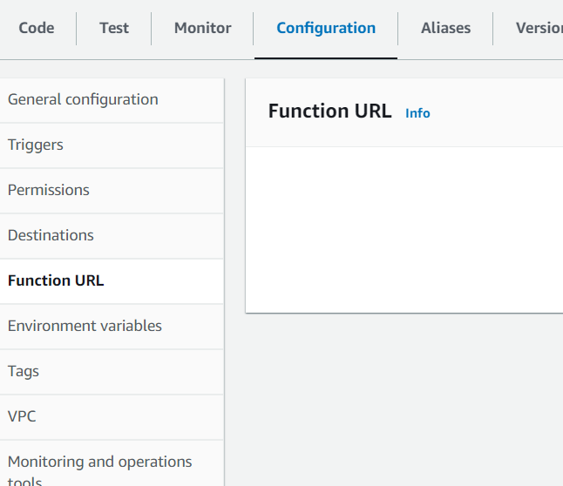

\

**5.….**.

**6.**

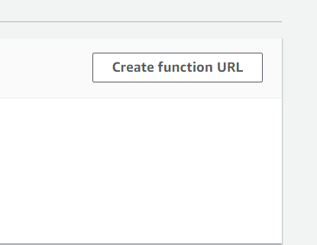

**Select Authorization type as “NONE” and Click on“Save”**

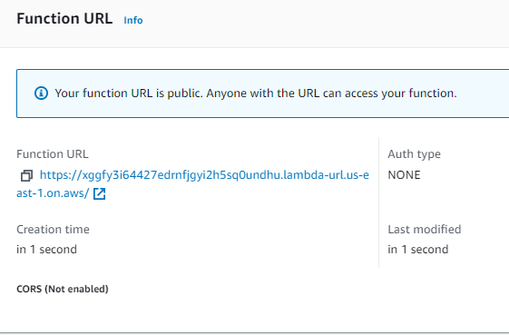

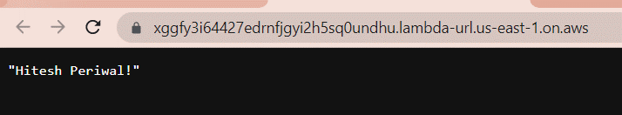

**Function URL is thus generated.You can use it access and view your deployed project.**

**7.….**.

**8.**

